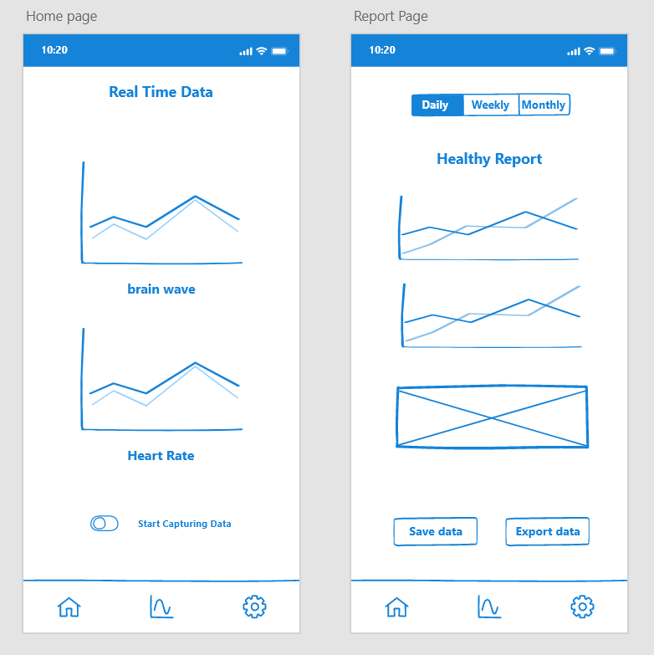Prototype could involve Customers and users in all processes. If the stakeholders find any problems or want to change the ideas of system design, it leads to timesaving. To help stakeholders validate the requirement and get an insight about how the software would look like, we drew low-fidelity prototypes.

Figure 1

The first image in Figure (1) is the app’s home page. Users can see the graph of real-time data captured by the app from wearable devices. This real time data report needs at least 30 minutes data source capturing to initialize. Then the report will refresh every minute. There is a switch button to help the user decide whether to start to capture data or not. If the connection interrupts, the application will remind user to check the equipment. When the time without signals is longer than 5 minutes, the system needs to re-gather data for another 30 minutes.

When the user clicks the middle button in the bottom navigation bar, the report page will show the second image in Figure (1). Daily, weekly and monthly reports can be chosen to see. These compositive reports include the average heart rate, peak heart rate and cardiogram. In addition, users can save these data to their mobile phone or export data to a computer if they want.

The setting page (Figure 2) contains three functions: connect to wearable devices, record, or display weight, and provide some options to the user. If customers use this app for the first time, they need to connect devices first. After this step, every time they click on this page, a connecting situation will be displayed.

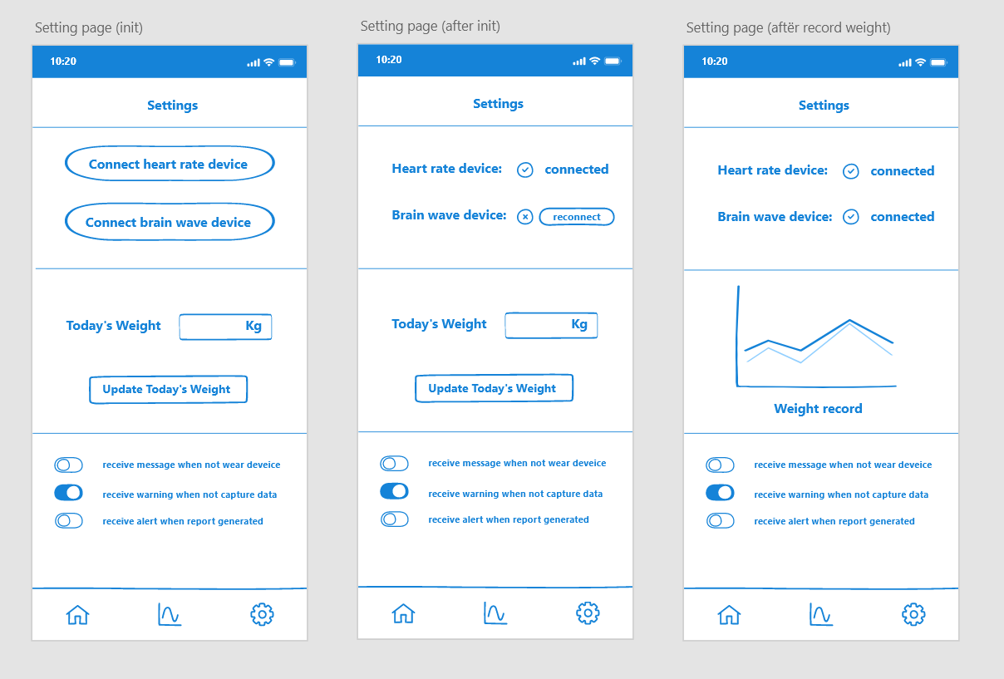Additionally, users could weigh themselves and record data on this page. The weight trend will show after that. Otherwise, user can change the message pushing mechanism for personalization.

Figure 2